Methods
- Overview
  - Brief introduction of the COSFIRE approach
  - Brief introduction about evaluation
- COSFIRE method
  - Overview
  - Two-stage approach: Configuration and Application
- Configuration
  - Given a prototype the system automatically configures a COSFIRE filter
- Application
  - First, apply Gabor filters
  - Second, blur and shift the Gabor responses
    - Why blur and why shift?
      - Blur: to allow for some tolerance in the preferred orientation and in the preferred relative position.
        - Sum versus Max
          - Sum is more efficient because it is a linear function, so it can be applied in the Fourier domain. Sum is not robust to noise
          - Max is less efficient but more effective.
      - Shift: such that the blurred responses meet at the same position, the one which we consider the center of the support of the concerned COSFIRE filter
  - Response of COSFIRE filter
    - Apply a pixel-wise multivariate function on the blurred and shifted Gabor filter responses. Here we use weighted geometric mean.

- Evaluation
  - Data sets
    - describe the data sets
  - Preprocessing
    - resizing
  - Configuration of COSFIRE filters
    - Why selecting random locations? And why 3?
  - Forming shape descriptor
    - For a given data set of k different models and for 3 COSFIRE filters for each model we form a feature vector of 3k elements. Each element is the maximum value of the corresponding COSFIRE filter.
  - Classification
    - Use the shape descriptor to create a feature vector for each of the given models. This means if there are 150 models then we create 150 feature vectors.
    - Similarly, we use the same shape descriptor to create a feature vector for each of the test images.
    - We k-nearest neighbour algorithm (here k=1) to classify the test images.
      - Equation of Euclidean distance
      - Definition of classification

- Experimental Results
  - Overview
    - For the first X data sets we run the experiments only once
    - However, for the rest we ....
    - We repeat the experiments for each data set for 3 times in order to compensate
  - Data set X
    - It consists of X different models and Y test images for each model.
    - The given test images are given in the same orientation and in the same scale of the models.
    - Noisy or not and to what degree

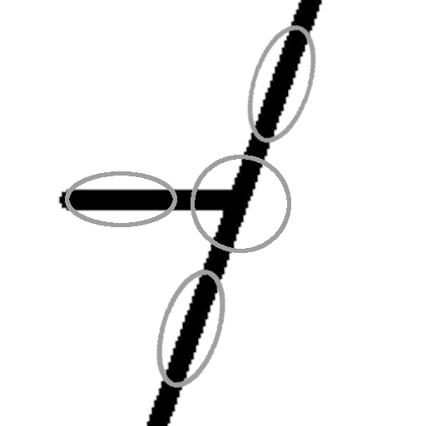
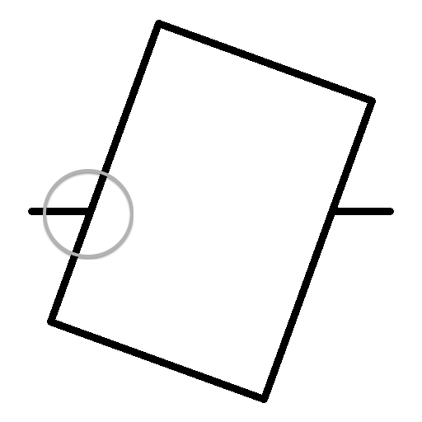
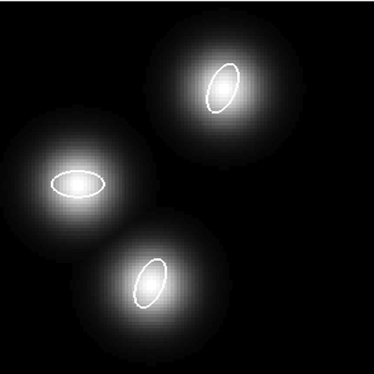



λ = 11.3, θ1= 90

λ = 11.3, θ1= 160

